Readme

  - How to use the document.
- Open this pdf in Microsoft word to edit the fields to enter data.
- Delete this read me page and then export document to PDF and upload to the app, so that a scenario can be created.

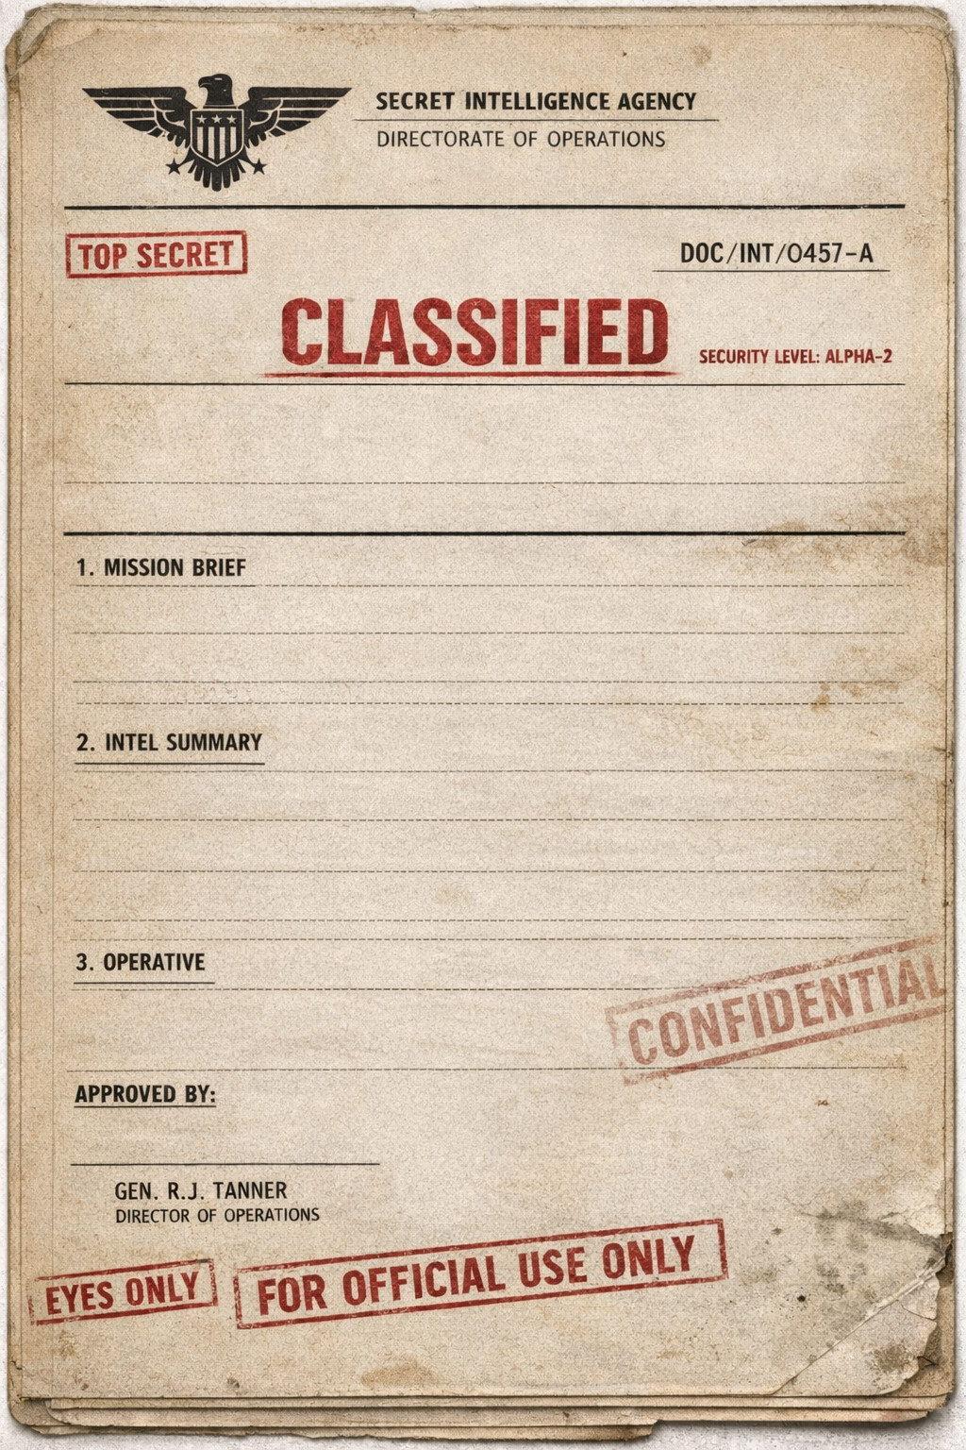

DATE: Click or tap here to enter text.
FILE NO: Click or tap here to enter text.
SUBJECT: Click or tap here to enter text.

Click or tap here to enter text.

Click or tap here to enter text.

Click or tap here to enter text.

Click or tap here to enter text.

